**Guide to using Hashtags and the Leaderboard**

Are you interested in tracking your group’s additions to the Missing Maps project? This guide will show you how to manually add a group hashtag to your OpenStreetMap (OSM) uploads and how to check those results using the leaderboard.

**What are changeset comments?**

Changeset comments are one way we track the accomplishments of the Missing Maps project. Every task in the Tasking Manager will have an assortment of these preloaded by the project administrator for their tracking purposes. These are found in two locations. First, they can be found under the Instructions tab on the main project page.

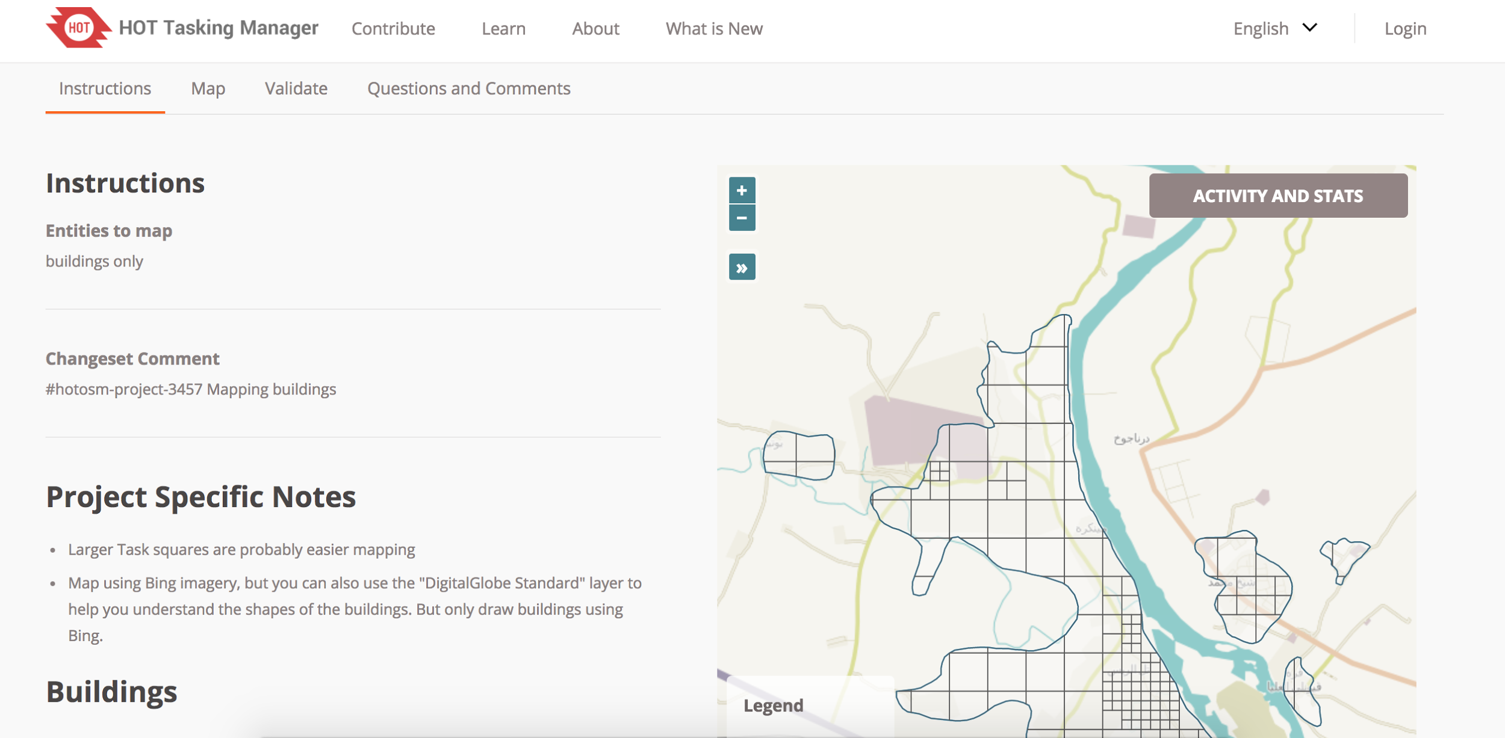

Secondly, they will also be displayed between the save and upload phase of your mapping. This is when you will be able to add your group’s hashtag.

**Adding a group hashtag:**

First, identify a unique name to use as your comment that is representative of your work. Consider things like #MSFTOrgTeam or #MSFTTeamNameGives. Share this hashtag with your entire group ahead of your event. Next, map as you usually would. You will add your hashtag between the Save and Upload phase. Once you are ready to upload your work, click the Save button as you usually would. Notice the changeset comments appear on the top left of your screen.

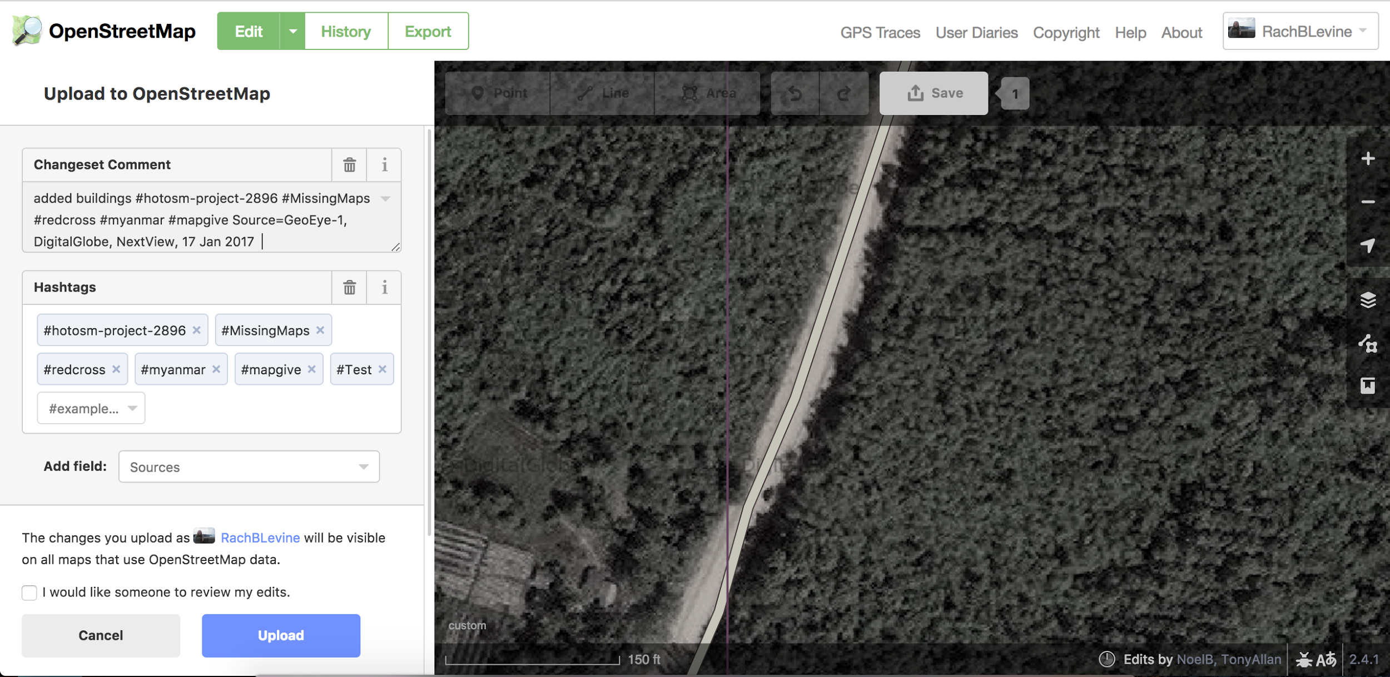

Now is your chance to manually type in your chosen hashtag. All you have to do is type it in after the preloaded comments.

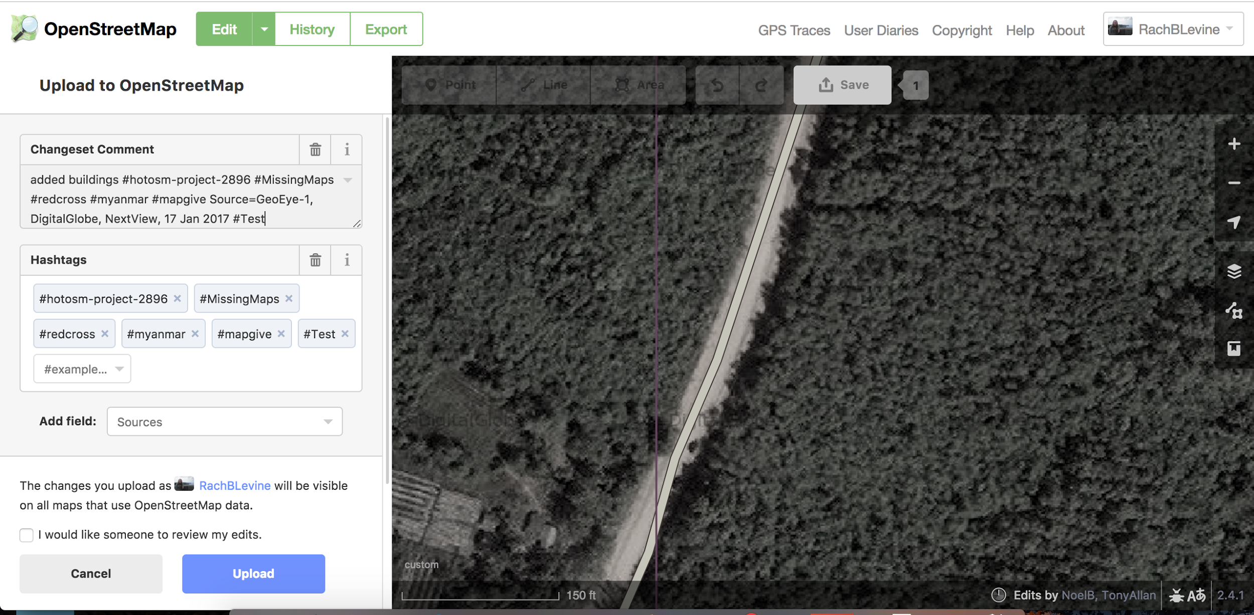

To finish committing your edits to OSM, click the Upload button as you normally would. Your hashtag will now autoload for the rest of your time mapping that square, however, it’s always a good idea to double check! **Note: Once you move on to your next square you will have to re-add the comment using the same steps above.**

**Accessing the Leaderboard:**

To check your results, please go to the [Missing Maps](http://www.missingmaps.org/) website. On the top right you will see a menu for “Discover”. In the drop-down select “Leaderboards”.

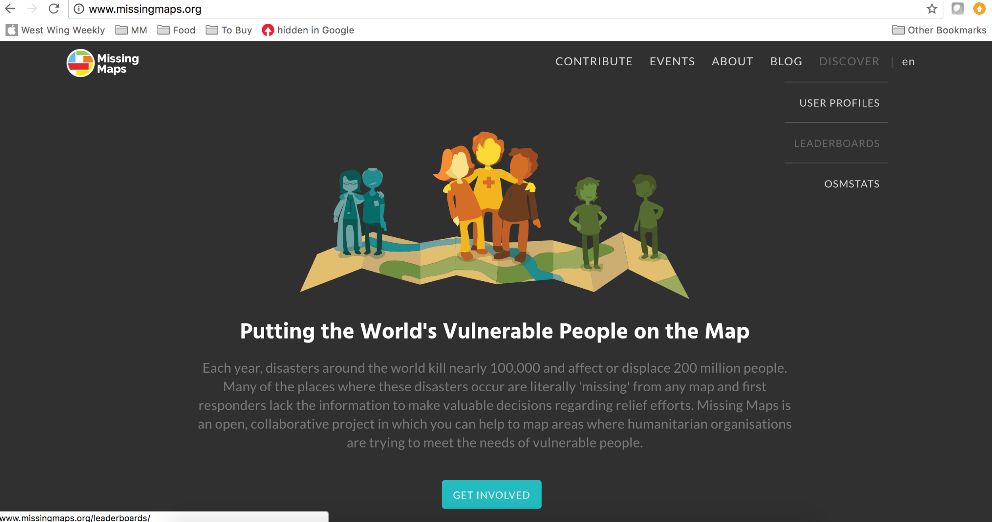

The results page for the entire Missing Maps project will load first. This will show you how many buildings the community has added and how many edits they have mapped!

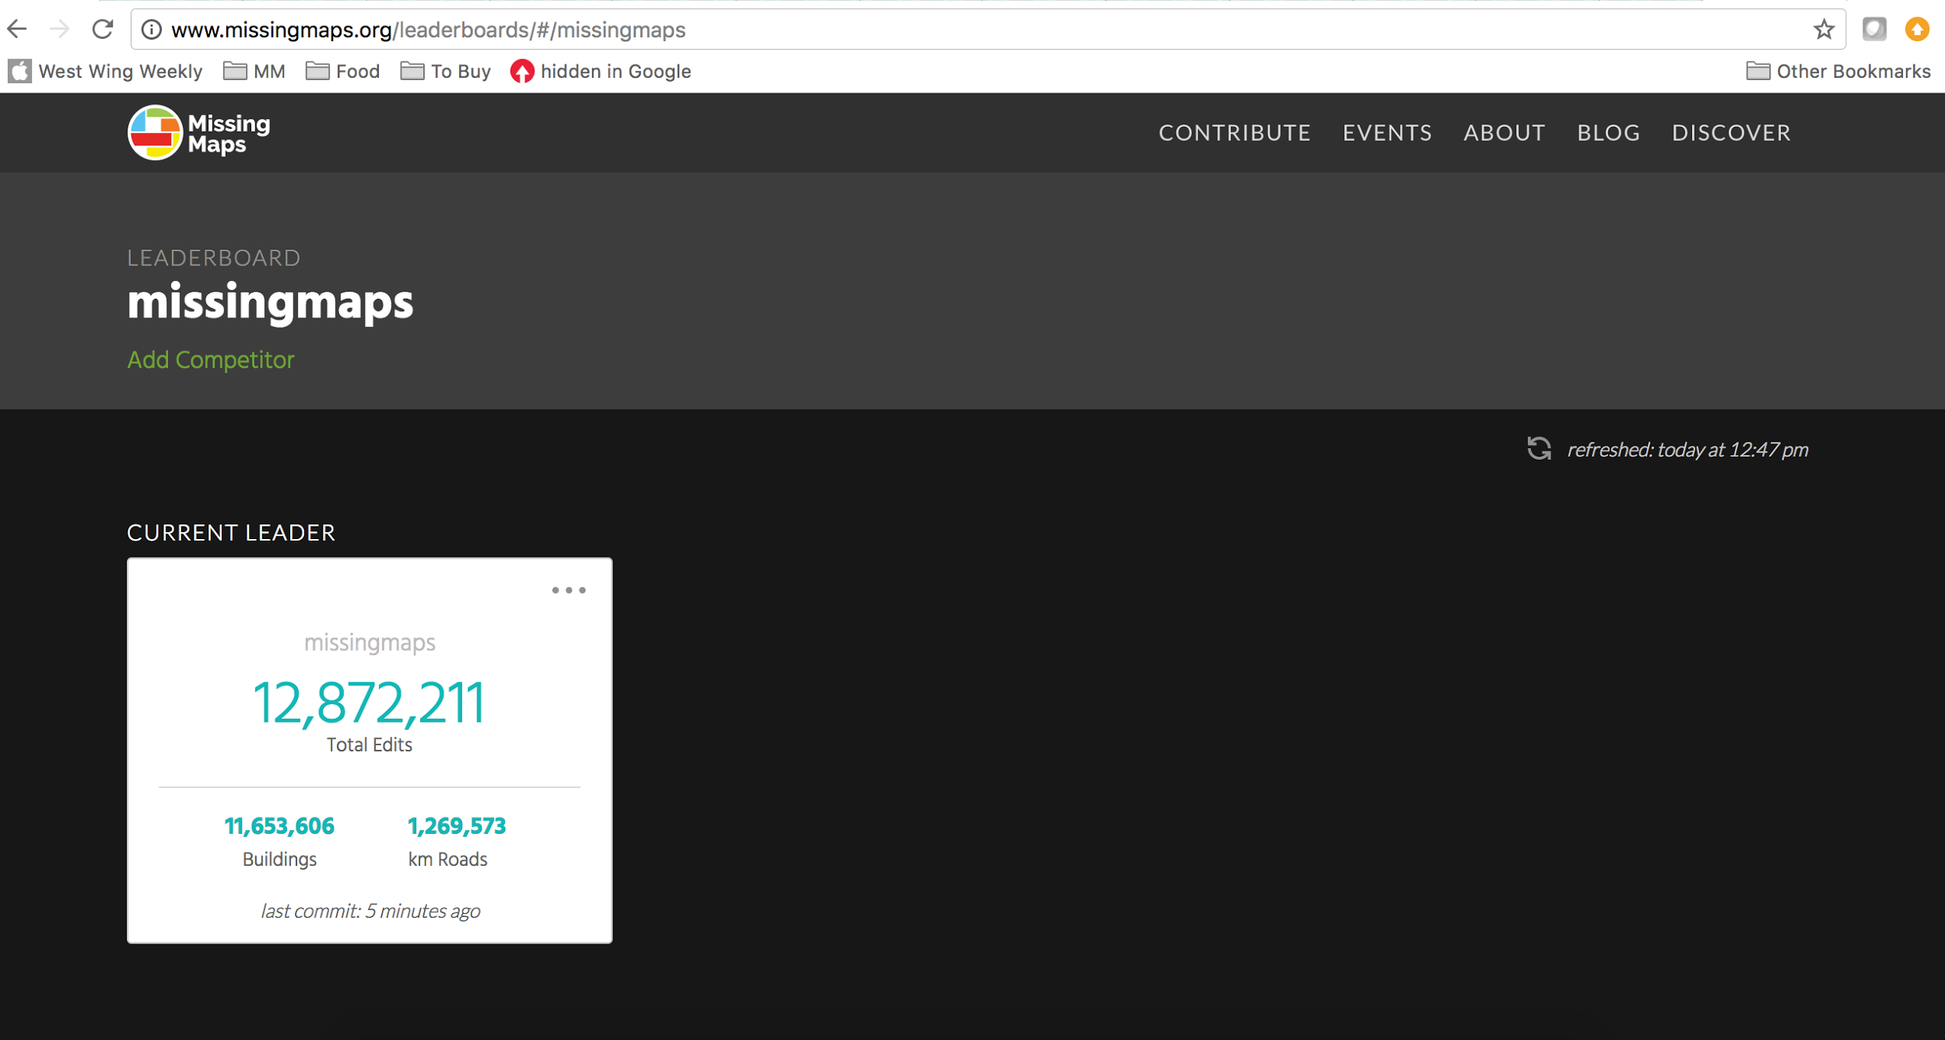

If you scroll down, you will be able to see the top mappers. You can sort this list by total edits, buildings mapped, km of roads mapped, or by when the user last mapped.

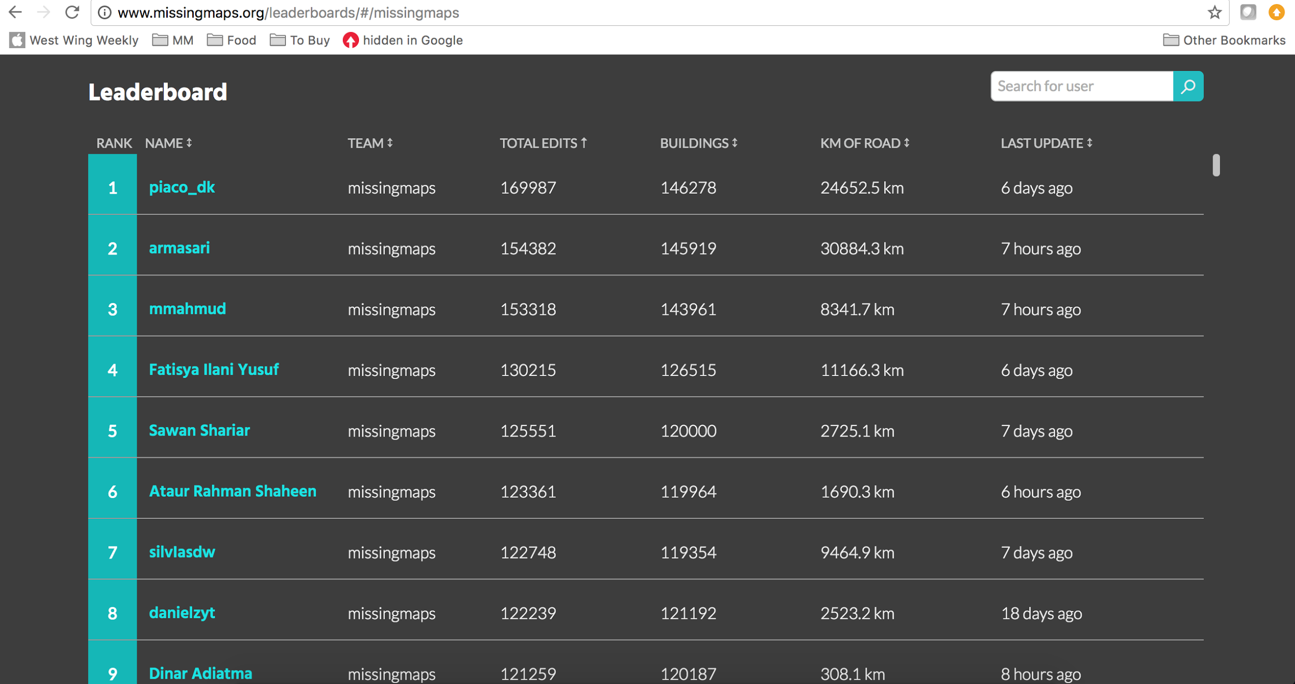

**Checking your results:**

To add your group’s hashtag to the display, click the “Add Competitor” button and type in your hashtag. You do not have to add the hashtag symbol (#) here.

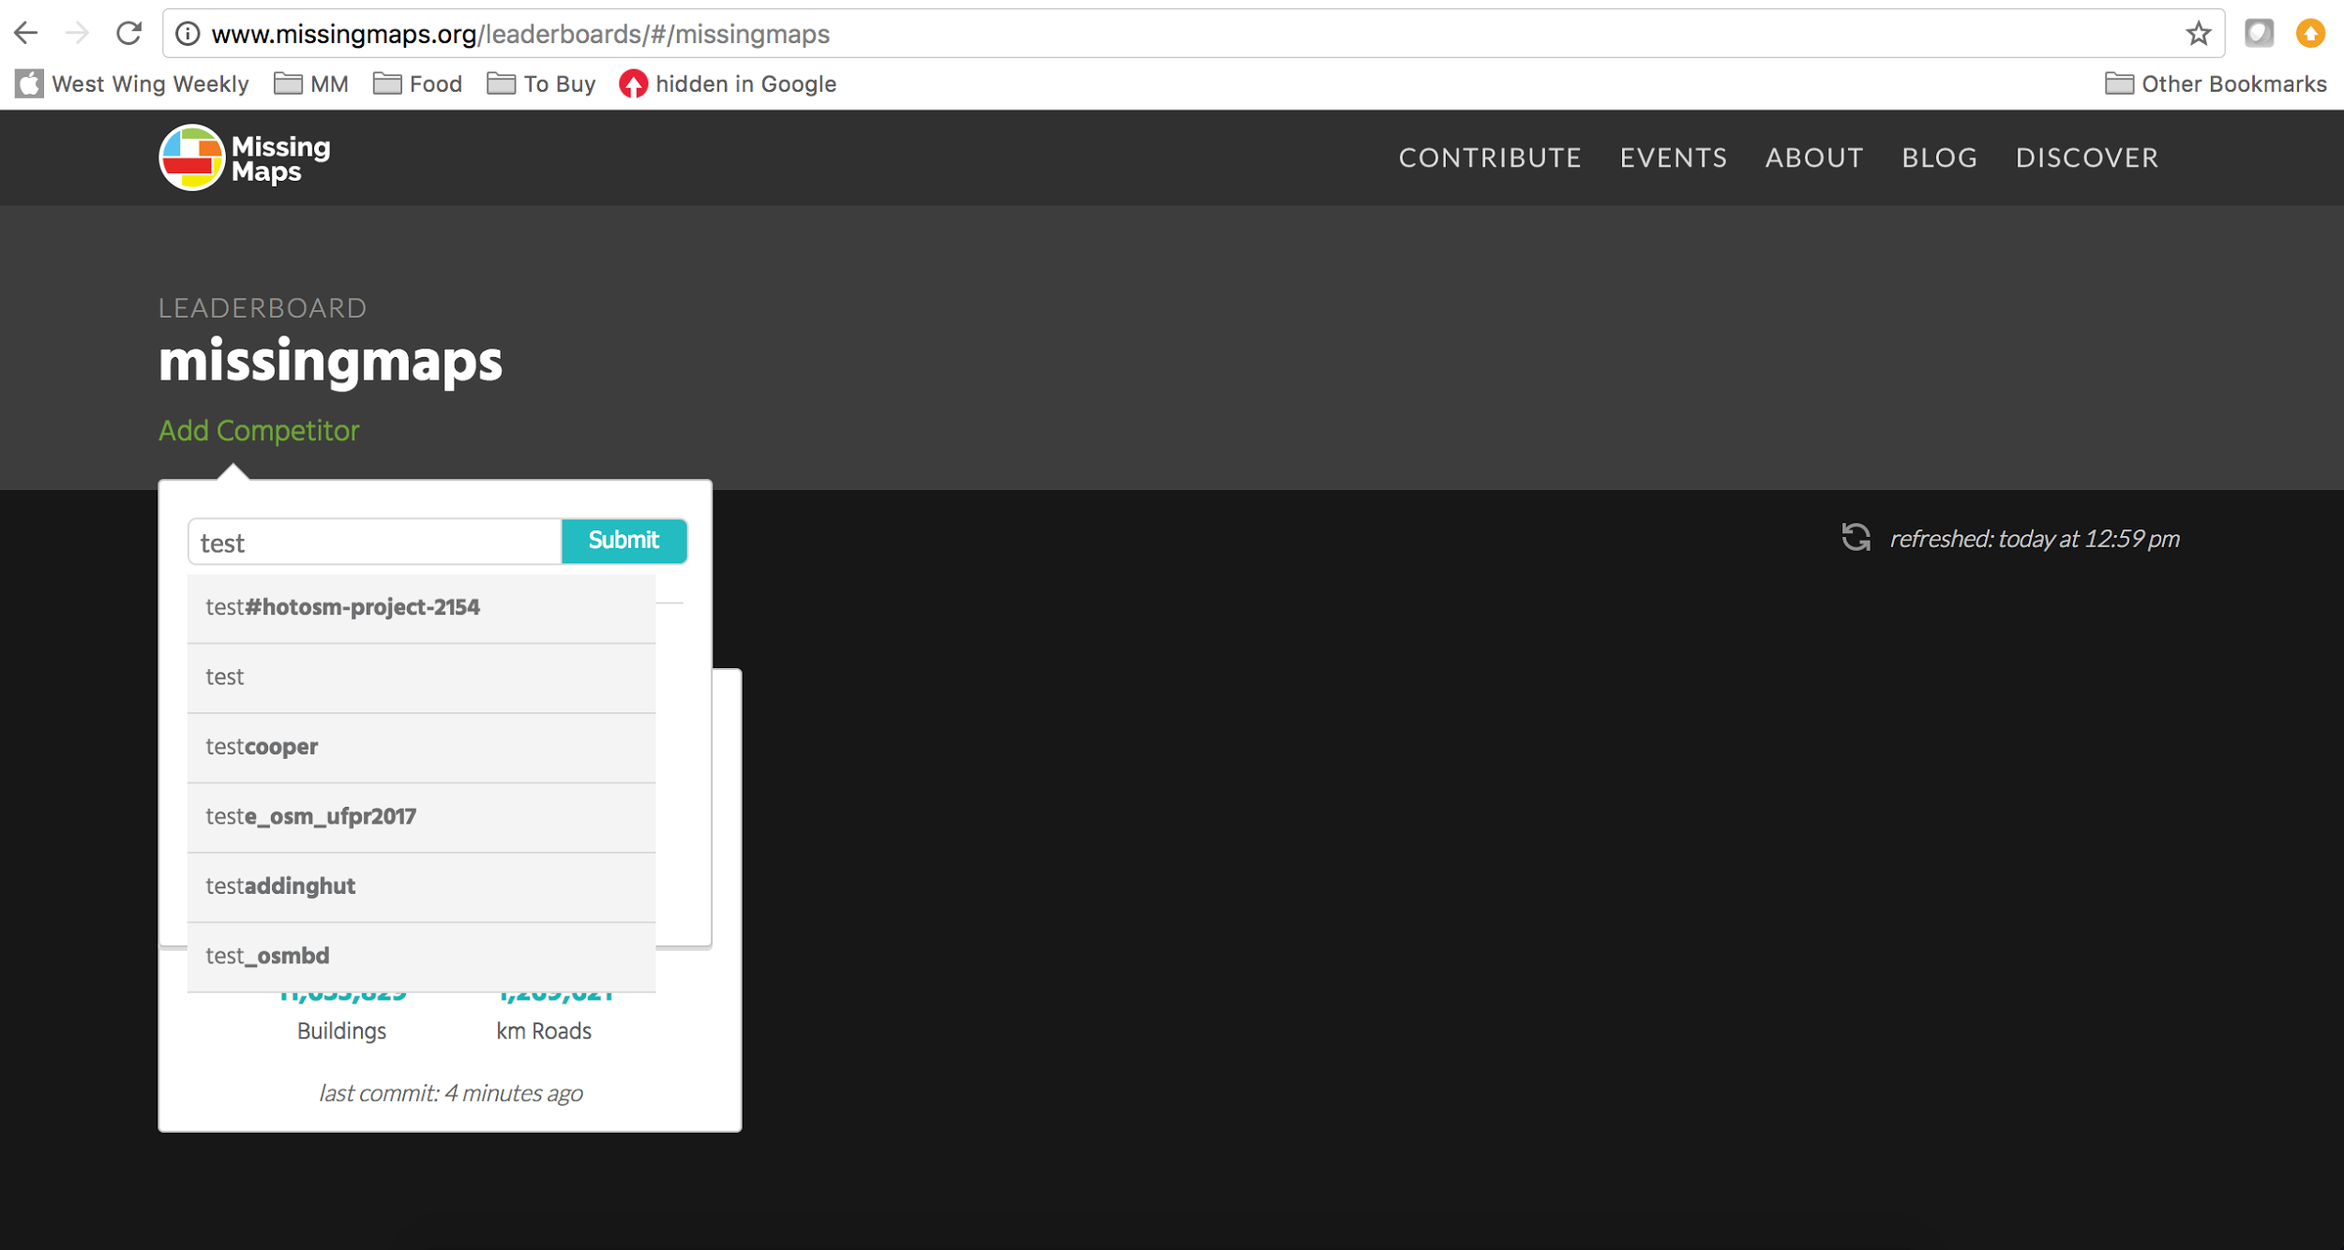

You will now see results for your group as well as the results for the overall program.

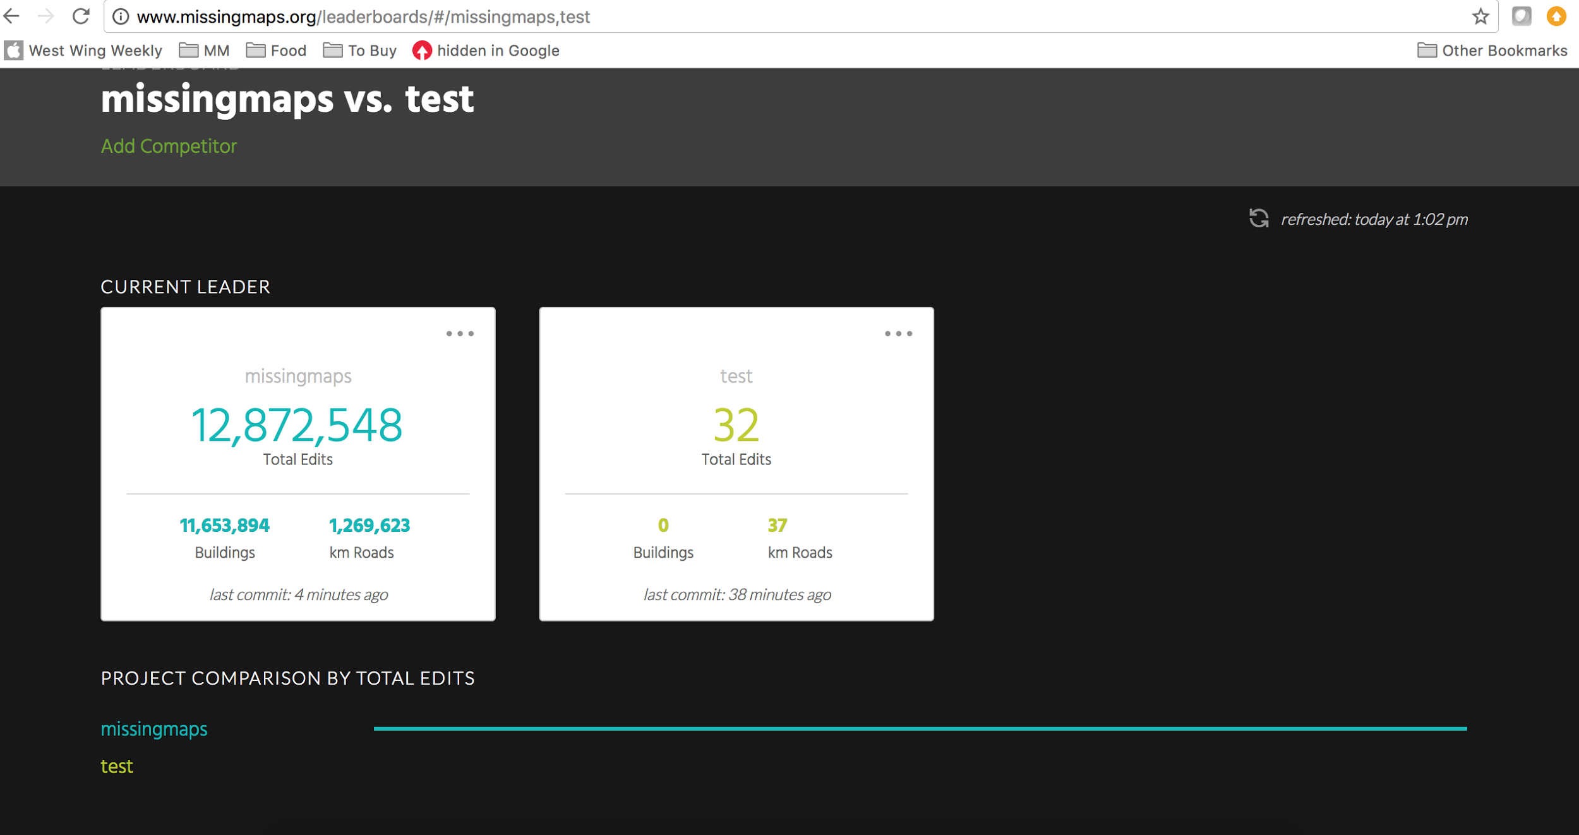

You will probably want to see results for only your group. To remove the overall program results, click the three dots on the top right corner of the Missing Maps totals box and click “Remove” to hide this group. You will now be able to scroll down to see individual results for only your group.

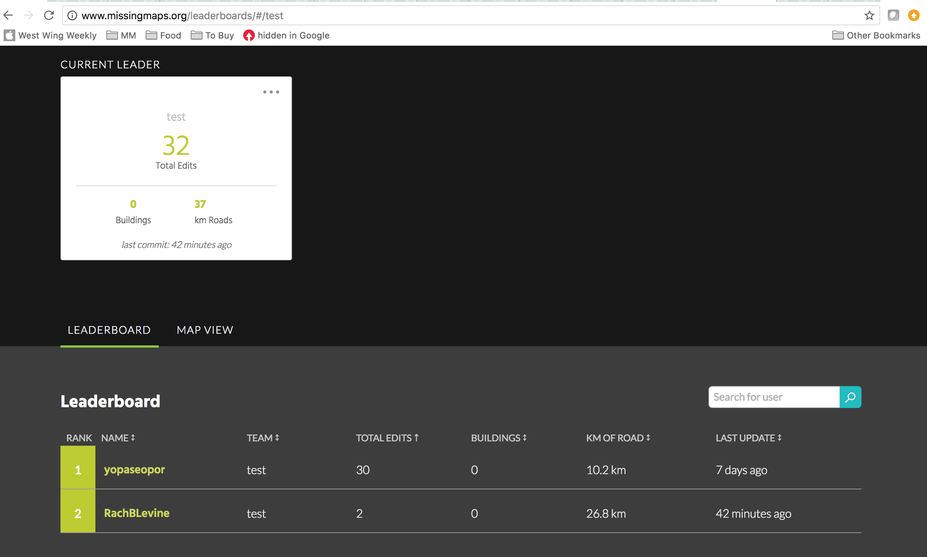

You can compare three changeset comments at a time. To add additional changeset comments to compare, follow the guidelines above. Happy Mapping!